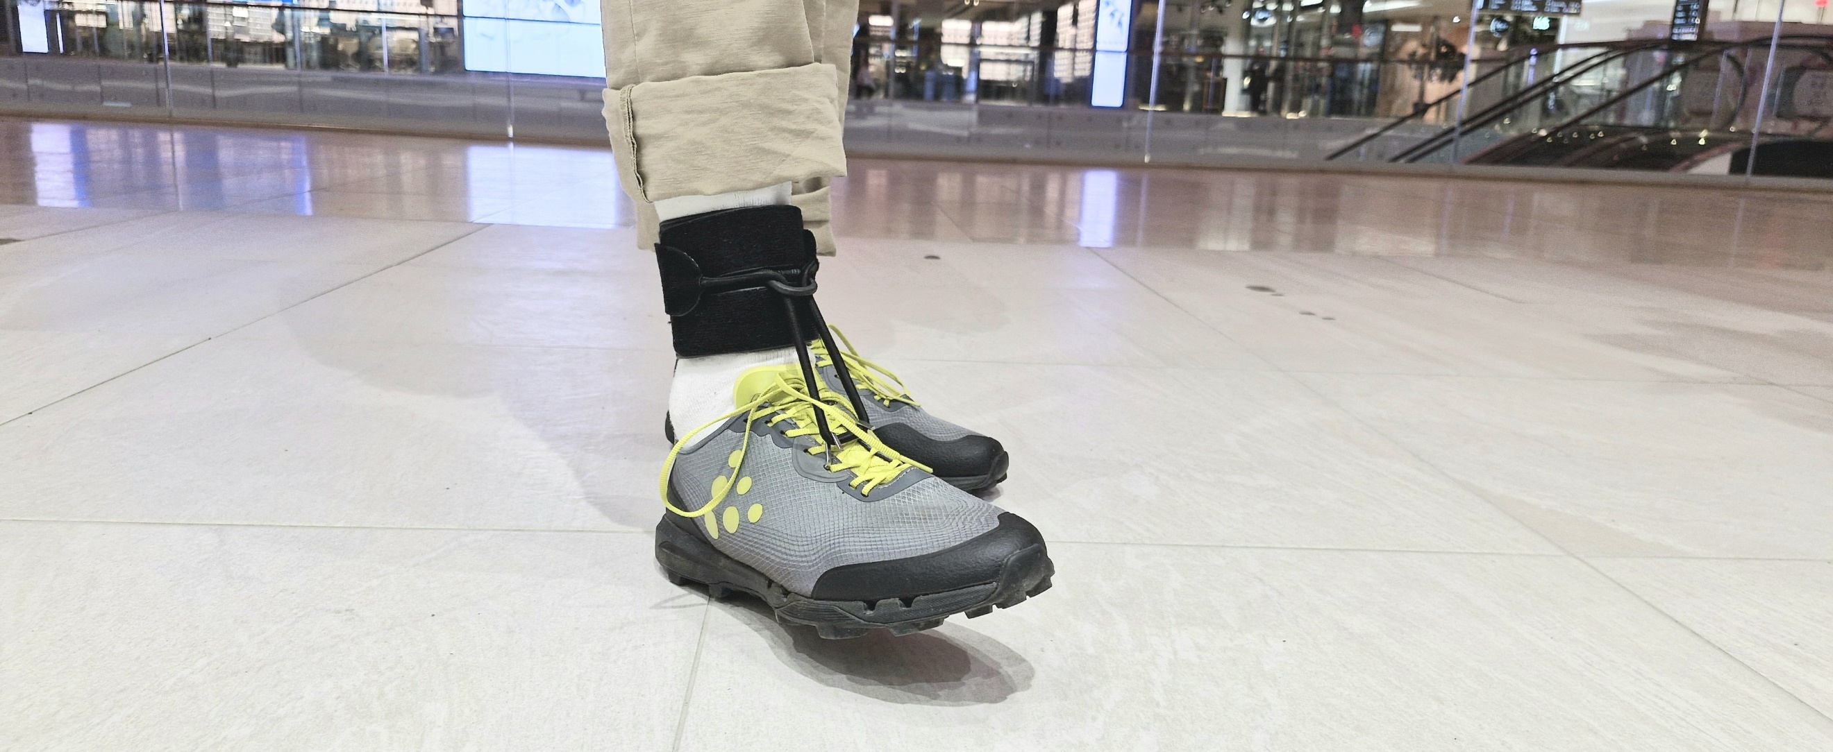
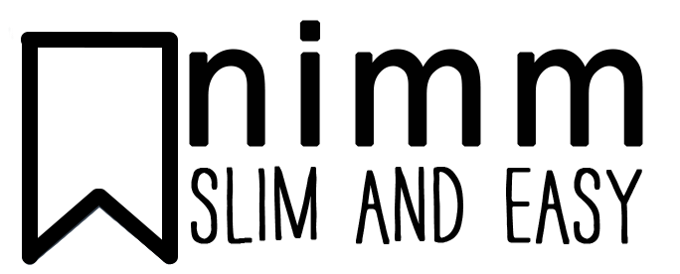

- Neat and handy aid for drop foot users
- Lifts the foot immediately after toe-off, preventing the user from worrying about tripping
- Made of leather that becomes softer with daily use
- Extra padding at tibia makes Nimm even more comfortable
- Universal design allows the user to choose whether to fasten the Velcro straps inward or outward
- Nimm Adjust is suitable for both children and adults
Nimm Adjust
Nimm Adjust AFO
Nimm Adjust is neat and handy, providing great support that helps users with drop foot return to an active life.
It lifts the foot immediately after toe-off, ensuring users can avoid obstacles such as carpet edges, thresholds, or even minor surface irregularities.
Neat and handy aid for drop foot patients
Crafted from genuine leather: soft on the skin and becoming more comfortable with daily use. Additional pads at the tibia enhance the orthosis' comfort.
Easy to Attach: The brace wraps securely around the ankle with Velcro straps. Its universal construction allows users to choose their preferred closure direction.
Adjustable Lift: The lift intensity can be adjusted in two ways: by repositioning the Velcro pad or relocating the hooks in the shoe.
Automatic Foot Lift: When walking, the elastic band automatically lifts the foot. Nimm Adjust is a discreet aid suitable for both children and adults.

Nimm Adjust AFO 
Art.No. | Product | Size | L/R | 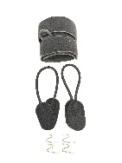 | 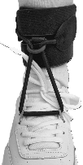
NA2-S | Nimm Adjust | Small/ child 12-17 cm | Bilateral
NA2-M | Nimm Adjust | Medium 15-20 cm | Bilateral
NA2-L | Nimm Adjust | Large 20-27 cm | Bilateral
NA2-XL | Nimm Adjust | X-Large >26 cm | Bilateral

Nimm Indoor
Art.No. | Product | Size | 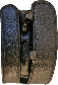 | 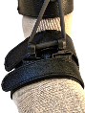
NI3-S | Nimm Indoor | Small/ child
NI3-R | Nimm Indoor | Right
NI3-L | Nimm Indoor | Left

Nimm Adjust parts
Art.No. | Product | Size
NAE-S/M | Nimm Adjust Elastic band | S/M 35 CM | 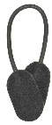
NAE-L/XL | Nimm Adjust Elastic band | L/XL 40 CM
NSH | Nimm S-hooks NSH /pair |  | 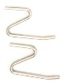
NPH | Nimm Plastic hook /ea |  | 